

WALCHAND COLLEGE OF ENGINEERING, SANGLI

**ELESA**

**ELECTRONICS ENGINEERING STUDENTS’ ASSOCIATION**

Email: [walchand.elesa@gmail.com](mailto:walchand.elesa@gmail.com) Website: [www.elesa.in](http://www.elesa.in)

**Date:- 22/9/2017**

**SECRETARIAL REPORT ON**

**Library Visit**

This year ELESA organised Library visit specially for first year electronics engineering student. The motto behind organizing this visit was to make first year student familiar with our college library. Every year library staff take session in the beginning of academic session of first year in order to make them familiar with system of library but this year due to late admission of first year students the session wasn’t arranged. We got lot of feedback from first year students about non understanding of library system. President Shubham Mhatre took initiative to organise the Library visit. We requested librarian of our library to keep library open after 5:30 pm on 22/09/2017 and they gave permission happily. He also appreciated ELESA for arranging this activity.

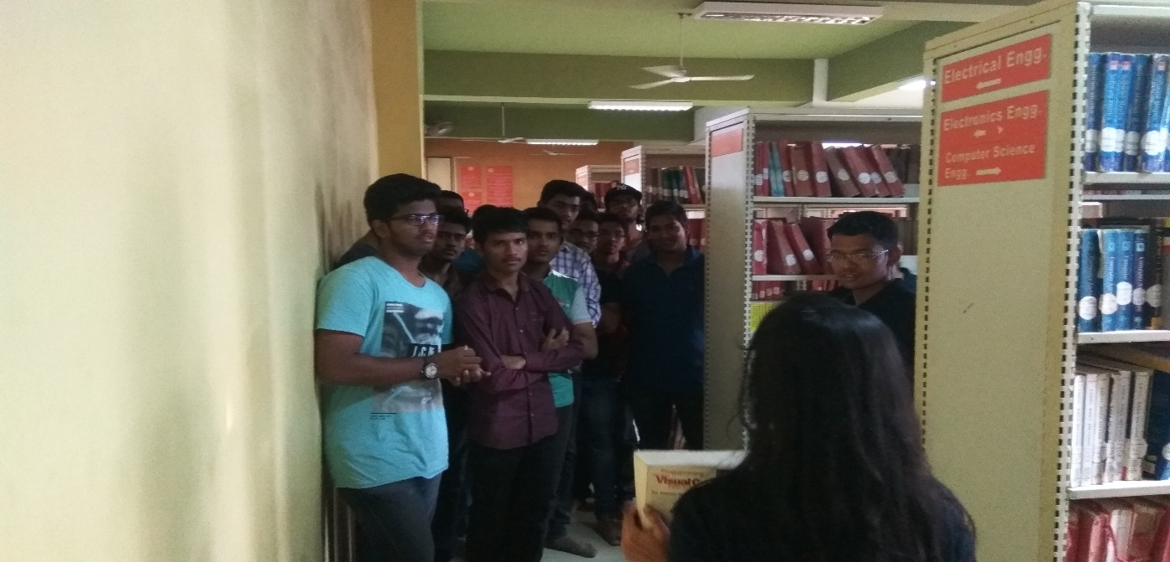

FY students gathered near library at 5:45 pm introductory session was organised and the flow of visit was discussed. The visit started with showing procedure of registering name on register. The importance of carrying library membership card to avail any of library facility was also explained to them. Later session on searching required book was done. All the codes of library for arranging books were explained in order to facilitate student. Students were then taken to magazine section and then to reference section. All the defined for each section were explained to students so that they should not make any mistakes while using the facility.

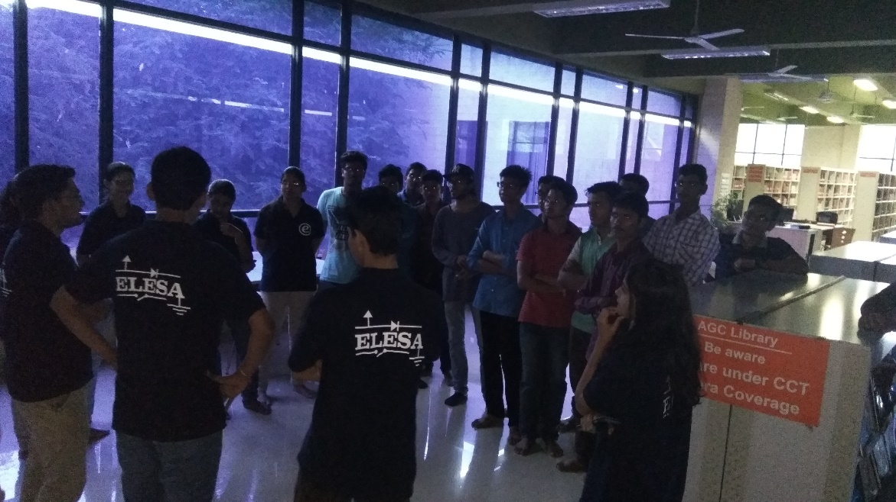

All other facilities of our library like availability of previous years examination papers, discussion rooms, communication room were shown to students. The procedure needed to follow for availing various facilities of library were also explained. Librarian sir shared his few but wise words with students. The session then concluded with feedback of FE’s. the positive feedback from FE’s raised the enthusiasms of board members.

Mr. Mahadev Mishal

Secretary,

ELESA